CMP-466: Machine Learning and Data Mining
Music Genre Classification using High-Level Audio Features

Colab: Group7_MLProject-2.ipynb
List of Authors:
Muhammed Hady - B00094926
Pranav Vivek - B00090976
Arya - B00097405

Abstract
This project addresses the challenge of automatic music genre classification at a massive scale, a critical task for modern music discovery and recommendation systems. Utilizing the Spotify Tracks Dataset, comprising 114,000 records across 114 balanced genres, we developed a reproducible, end-to-end pipeline focused on high-level, tabular audio descriptors such as danceability, energy, and tempo. The study implemented transparent preprocessing, including Z-score standardization, One-hot encoding, and Principal Component Analysis (PCA) to mitigate feature redundancy. We benchmarked three classical models: Decision Trees, K-Nearest Neighbors (KNN), and Naïve Bayes. Our results indicate that while all models significantly outperformed the random-guess baseline of ~0.88%, the optimized Decision Tree achieved the highest performance on the original feature set with an accuracy of 25.70% and a Macro F1-score of 0.25. Conversely, KNN benefited most from dimensionality reduction, reaching its peak performance with an accuracy of 24.42% and Macro F1-score of 0.24 after PCA transformation. The findings highlight the inherent difficulty of high-cardinality classification, as significant audio characteristic overlaps between 114 genres create a performance ceiling for traditional tabular models.

- Introduction
Music streaming platforms organize and recommend content at massive scale, which makes automatic music genre classification an important task for search, discovery, playlisting, and recommendation [6]. In practice, genre prediction can be approached using (a) raw audio and signal-processing features (e.g., spectrograms/MFCCs) or (b) high-level audio descriptors and metadata provided by platforms such as Spotify (e.g., danceability, energy, loudness, valence, tempo). Our project focuses on the second setting: tabular, high-level audio features, which are attractive because they are widely available, computationally cheaper than raw-audio pipelines, and can support more interpretable modeling.

Prior research using Spotify-style datasets shows that classical supervised learning can be effective, with tree-based approaches often performing strongly. For example, [7] compared Naïve Bayes, k-NN, Decision Trees, and Random Forests for Spotify genre classification and found Random Forest achieved the best accuracy (≈79.4%), closely followed by Decision Trees (≈79.3%). Similarly, recent work on Spotify Tracks data for popularity/hit prediction also finds decision-tree ensembles competitive and highlights the importance of using metrics beyond accuracy (precision/recall/F1) and addressing dataset issues like imbalance and leakage [8].

Despite these advances, existing solutions have limitations that motivate our work. First, many papers either focus on different targets (e.g., hit prediction rather than genre) or do not fully document preprocessing, feature encoding, and hyperparameters, which makes results difficult to reproduce and compare fairly. Second, multi-class genre classification at large label counts (e.g., 100+ genres) is challenging because genres overlap in audio characteristics, so reporting only overall accuracy can hide failure modes across specific genres.

Our contribution is a reproducible end-to-end pipeline for multi-class genre classification using the public Spotify Tracks Dataset (114,000 tracks; 114 balanced genres) and its high-level audio features. We (1) implement transparent preprocessing (feature selection, encoding of categorical/binary attributes, and standardization of continuous features), and (2) benchmark interpretable classical models used in the literature (e.g., k-NN and decision-tree-based methods) under consistent evaluation. This addresses common limitations in prior work by emphasizing clarity, comparability, and practicality for genre modeling using tabular Spotify audio descriptors.

- Literature Review
The following summary organizes the literature review into a comparison table, followed by detailed overviews that synthesize the findings and critical evaluations of each study.

Ref | Purpose | Methods | Dataset | Metrics & Values
[2] | Investigate trait effects (energy, acousticness, year) on song popularity. | Regression models and correlation analysis. | Spotify Web API datasets with temporal coverage (Public). Similar to our dataset but with explicit temporal coverage. | Coefficients, p-values, R^2.
[3] | Predict hit vs. miss; analyze genre-trait relationship shifts over decades. | Binary classification (RF, Neural Network/LVQ), ADF Test. | Kaggle Hit Predictor (1960–2019): 2000s (5,872 tracks), 2010s (6,398); manual genre labels for 700/decade (Public & Private). | RF and NN performance; ADF p-values for time-change.
[4] | Forecast popularity using intrinsic audio drivers and ML. | RF Regressor, GBM, Simple Linear Regression. | Spotify/Kaggle dataset (114,000 records) (Public). | RF: R^2 = 0.6137, MSE = 190.61; Classification: 0.76 accuracy.
[5] | Develop robust genre classifier via parallel CNN architectures. | Parallel CNN (PCNN) with CapSA hyperparameter optimization. | GTZAN (1,000 tracks) and Extended-Ballroom (Public). | 96.20% Accuracy; 96.21% Precision; 0.99 AUC.
[6] | Efficient genre categorization via feature selection/tuning. | RF, XGBoost, KNN, SVM, Logistic Regression; Grid Search. | Kaggle dataset (50,005 songs) (Public). | RF Accuracy: 99.60% (reduced to 99.48% with top 3 features).
[7] | Identify best-performing classic supervised learning model for genre. | Naïve Bayes, k-NN, RF, Decision Tree; cross-validation. | Kaggle Spotify song dataset (Public). | RF: 79.40% Accuracy; Kappa = 0.576. DT: 79.30% Accuracy.
[8] | Binary "hit" prediction using 80th percentile threshold. | Logit, SVM, RF, NN; stratified 5-fold CV; class weighting. | Spotify Tracks Dataset (114k records) (Public). | RF: 0.728 Accuracy, 0.736 F1-score; SVM: 0.752 Recall.

Research in [2] confirms that audio traits and temporal information interact significantly, noting that the influence of features like energy and acousticness fluctuates across decades. While the study effectively demonstrates that metadata carries a substantial temporal signal, justifying the use of release-year derived labels as targets, it does not implement a dedicated decade classifier.

The findings in [3] suggest that the relationship between genre and audio features is non-static, with time-series tests (ADF) rejecting the null hypothesis of "no change" between the 2000s and 2010s. Critically, while the study provides strong performance via Random Forest, its genre annotation is limited to a small subset (700 tracks per decade), which may introduce bias and limit the broader temporal generalizability of the results.
The work in [4] identifies danceability, energy, and loudness as the primary drivers of track popularity, with Random Forest preferred for its ability to model complex, non-linear relationships. However, a critical review reveals a lack of dimensionality reduction (PCA) to address multicollinearity. Furthermore, the model struggled with outliers at the extremes of the popularity spectrum, likely due to the omission of external cultural and marketing data.

In [5], by utilizing parallel architectures across GTZAN (96.20% accuracy) and Extended-Ballroom (96.08%) datasets, a wide range of spectral and temporal details are successfully captured, with the CapSA algorithm significantly outperforming traditional grid search for hyperparameter tuning. Despite the near-state-of-the-art accuracy, the approach is computationally intensive and operates as a "black box," lacking the semantic interpretability found in traditional tabular machine learning models.

The findings in [6] highlight that reducing model complexity to just three key features (popularity, acousticness, and danceability) can drastically optimize training time (from 14.95ms to 0.16ms) without a meaningful loss in accuracy. A potential critique is that the near-perfect accuracy (99.6%) on a Kaggle dataset may indicate high feature correlation or data patterns specific to that dataset, which may not translate to more diverse, "real-world" audio streams.

According to [7], tree-based methods demonstrate efficacy over Naïve Bayes and k-NN for genre classification. However, the study is limited by a lack of detail regarding exact preprocessing choices and hyperparameter settings. Additionally, the reliance on accuracy and Kappa values without reporting macro-F1 scores makes it difficult to assess the model's performance on imbalanced multi-class genres.

The work in [8] demonstrates that among the four models tested (Logistic Regression, SVM, Random Forest, Neural Network), 'hits' differ systematically from 'non-hits' in terms of danceability and loudness, with Random Forest providing the most robust F1-score. A critical limitation noted is the potential for data leakage, as tracks by the same artist appearing across different cross-validation folds can artificially inflate performance metrics. Furthermore, the time-varying nature of popularity scores means the "hit" labels may not remain valid out-of-sample.

Summary of Motivation and Objectives
Current literature proves that high-level audio features are effective for predicting musical trends. However, most studies are limited to small datasets with only 10 to 13 genres. Research often favors complex ensemble models or "black box" deep learning architectures that, while accurate, lack interpretability and require significant computational resources. Furthermore, many existing papers overlook the impact of feature redundancy and fail to document the specific preprocessing choices that are vital for model reproducibility.
These shortcomings motivate the following objectives for this project:
- Evaluate High-Cardinality Classification: Perform robust genre classification across a significantly larger label set (114 genres) to test model scalability.
- Optimize Feature Efficiency: Implement and evaluate dimensionality reduction techniques to address feature redundancy and mitigate the "curse of dimensionality."
- Compare Traditional Model Architectures: Contrast the performance of various traditional machine learning models to identify which logic better suits high-level musical metadata.
- Refine via Systematic Tuning: Optimize model parameters to maximize accuracy while maintaining the interpretability and transparency of the classification process.

- Methods and Datasets
  - Dataset
Source and Type: The dataset is a public tabular collection sourced from Kaggle and Hugging Face, curated by Maharshi Pandya. It consists of high-level acoustic features and metadata for a wide array of musical tracks extracted via the Spotify Web API [1].
Size and Shape: The dataset contains 114,000 records and 21 columns, resulting in a dataset shape of (114000, 21).
Features: The 21 features represent a mix of metadata and audio descriptors:
- Metadata: track_id, artists, album_name, and track_name.
- Numerical/Audio Features: popularity, duration_ms, danceability, energy, key, loudness, mode, speechiness, acousticness, instrumentalness, liveness, valence, tempo, and time_signature.
- Boolean: explicit.
- Target Label: track_genre.

Class Labels and Distribution: The target variable for this project is track_genre. The dataset covers 114 unique musical genres. The class distribution is perfectly balanced, with 1,000 records assigned to each genre, ensuring that no single class biases the training process.
Descriptive statistics: Descriptive statistics for the dataset’s continuous numerical features can be seen below:

Feature | Mean | Std Dev | Min | 25% | 50% (Median) | 75% | Max
Popularity | 33.24 | 22.31 | 0.00 | 17.00 | 35.00 | 50.00 | 100.00
Duration (ms) | 228,029 | 107,298 | 0.00 | 174,066 | 212,906 | 261,506 | 5,237,295
Danceability | 0.57 | 0.17 | 0.00 | 0.46 | 0.58 | 0.70 | 0.99
Energy | 0.64 | 0.25 | 0.00 | 0.47 | 0.69 | 0.85 | 1.00
Loudness (dB) | -8.26 | 5.03 | -49.53 | -10.01 | -7.00 | -5.00 | 4.53
Speechiness | 0.08 | 0.11 | 0.00 | 0.04 | 0.05 | 0.08 | 0.97
Acousticness | 0.31 | 0.33 | 0.00 | 0.02 | 0.17 | 0.60 | 1.00
Instrumentalness | 0.16 | 0.31 | 0.00 | 0.00 | 0.00 | 0.05 | 1.00
Liveness | 0.21 | 0.19 | 0.00 | 0.10 | 0.13 | 0.27 | 1.00
Valence | 0.47 | 0.26 | 0.00 | 0.26 | 0.46 | 0.68 | 1.00
Tempo (BPM) | 122.15 | 29.98 | 0.00 | 99.22 | 122.02 | 140.07 | 243.37

  - Data Preprocessing
Listwise deletion
This method involves the complete removal of any observation containing one or more missing values. By utilizing only "complete cases," the integrity of the remaining statistical distributions is preserved. This approach is standard when the missing data occurs at random and the resulting loss in sample size does not compromise the statistical power of the dataset.

Feature Selection
Feature selection is the process of isolating the most relevant variables for use in model construction. By manually excluding metadata, such as unique identifiers, names, and administrative indices, the model is prevented from learning noise or memorizing specific instances. This reduction in dimensionality improves computational efficiency and forces the algorithm to rely on generalizable patterns within the musical attributes.

Binary Conversion
Categorical variables with exactly two states are transformed into a boolean integer format. This involves assigning a value of 1 to the presence of a trait and 0 to its absence. This mapping provides a computationally efficient representation for binary logic without the need for high-dimensional expansion.

One-hot Encoding
One-Hot Encoding transforms categorical variables into a series of binary columns, where each column represents a unique level of the original feature. For a variable with n categories, n new features are created; a value of 1 is assigned to the active category, while all others are set to 0. This method is critical for non-ordinal data, as it prevents the model from interpreting arbitrary numerical assignments as a mathematical hierarchy.

Label Encoding
Label Encoding is a process where each unique category in a feature is assigned a distinct integer. Unlike One-Hot Encoding, this does not increase the dimensionality of the dataset. It is primarily utilized for target variables in multi-class classification, providing the model with a discrete numerical index for each specific class.

Standardization (Z-score Scaling)
Standardization rescales continuous features so that they share a common distribution. By centering the data around a mean of zero and scaling by the standard deviation, features with different units are brought to a comparable magnitude. This ensures that the objective function of the model is not dominated by features with inherently larger scales.
The transformation is defined by the formula:
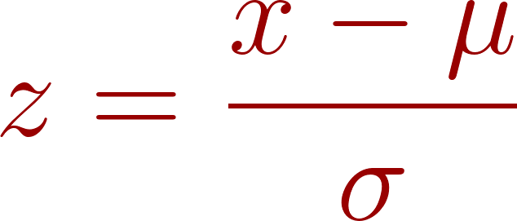
Where:
-  is the original feature value.
-  is the mean of the feature.
-  is the standard deviation of the feature.

  - Machine Learning Algorithms
This section outlines the supervised learning algorithms utilized for the multi-class genre classification task.

    - K-Nearest Neighbors (KNN)
The KNN algorithm is a non-parametric, instance-based learning method that classifies a data point based on the majority vote of its neighbors. It assumes that similar tracks exist in close proximity within the feature space. The model's behavior is optimized by tuning the number of neighbors (), the weighting function, and the distance metric.

Distance Metrics
The similarity between feature vectors is calculated using the Minkowski distance, a generalized metric:
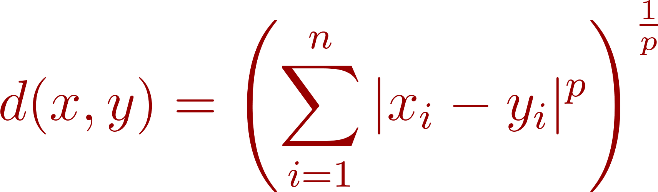
By adjusting the power parameter , the algorithm evaluates different geometric relationships:
- Manhattan Distance ():
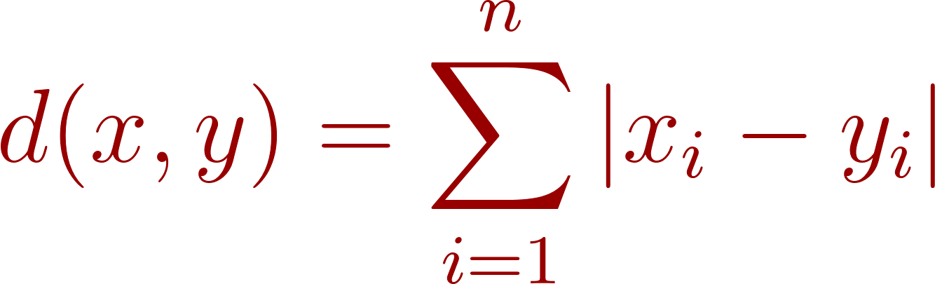
- Euclidean Distance (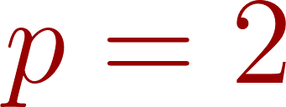):
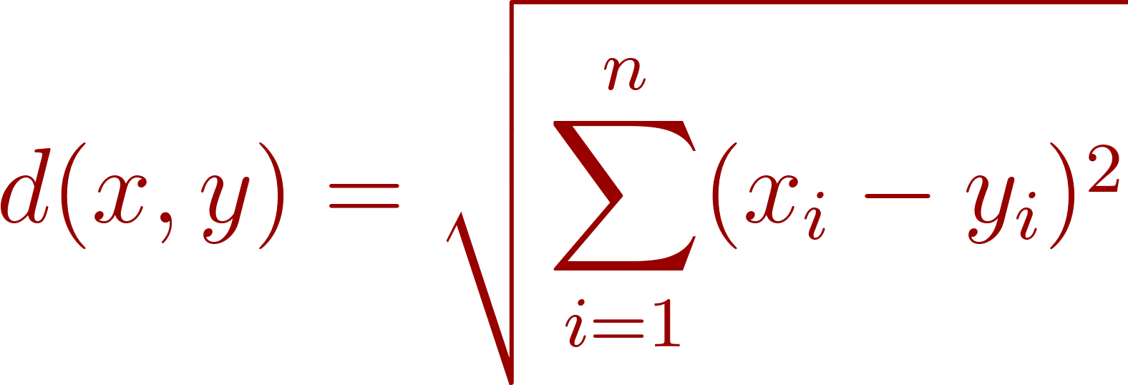

Weighting Functions
The influence of each neighbor on the final classification is determined by the weighting hyperparameter. When using distance-based weighting, the weight  is typically the inverse of the distance:
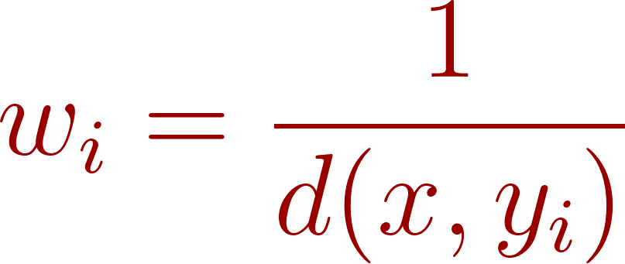

    - Decision Trees
A Decision Tree is a hierarchical model that partitions the dataset into increasingly homogeneous subsets. The algorithm performs recursive binary splits at each node to maximize the "purity" of the resulting branches.
To determine the optimal split, two primary impurity criteria are often used:
- Gini Impurity (G):
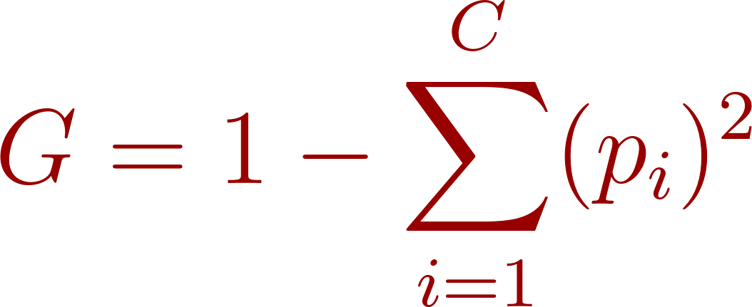
- Entropy (H):
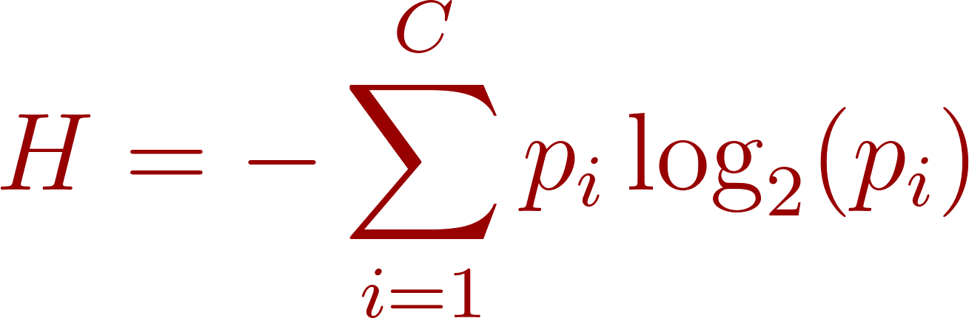

    - Naïve Bayes
Naïve Bayes is a probabilistic classifier based on Bayes' Theorem, operating under the assumption of feature independence.
Bayes' Theorem:
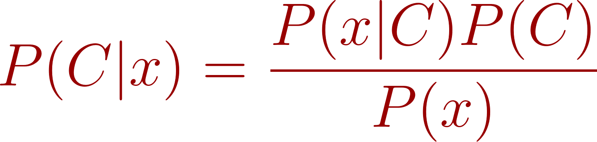

The model handles different feature distributions using specific variants:
- Gaussian Naïve Bayes:
Utilized for continuous audio features, assuming a normal distribution for each class:
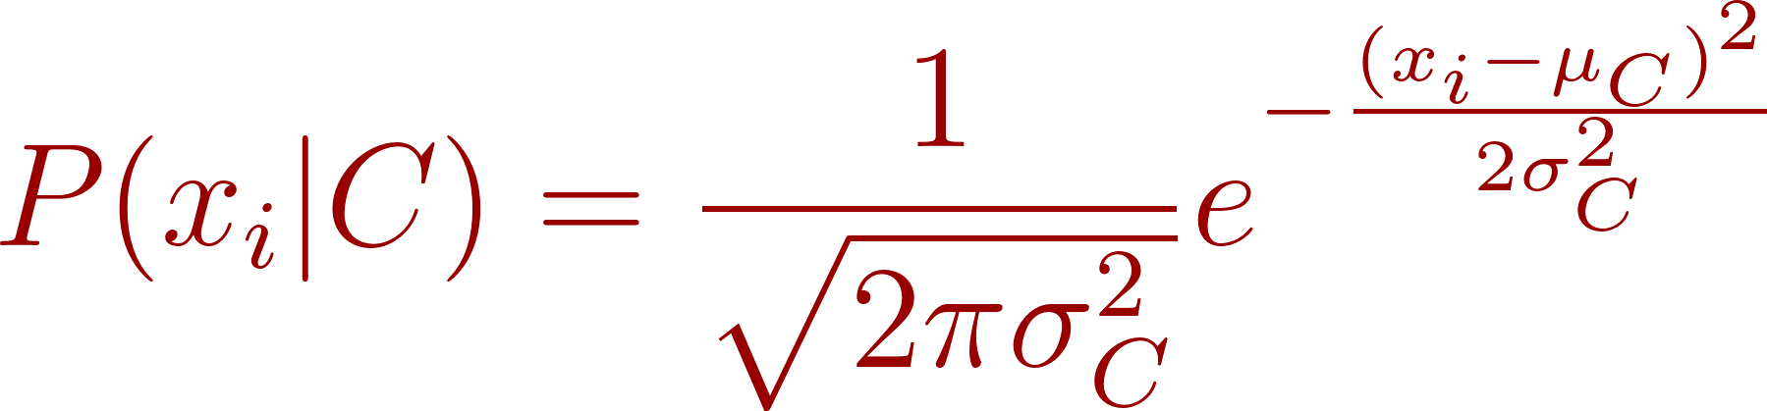
- Bernoulli Naïve Bayes:
Used for features that are inherently binary:
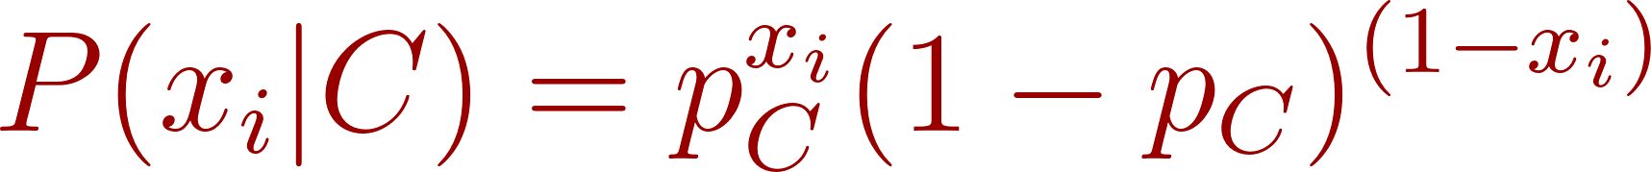
- Multinomial Naïve Bayes:
Calculates the probability of a specific feature combination, primarily used for discrete counts:
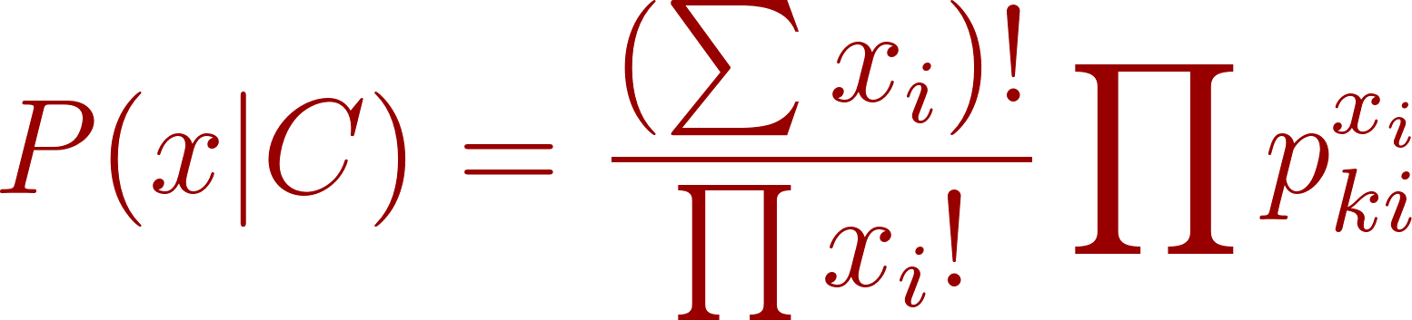

  - Feature Selection and Dimensionality Reduction
This section describes the dimensionality reduction technique applied to the dataset to optimize model performance and reduce computational requirements.

Principal Component Analysis (PCA)
PCA is an unsupervised linear transformation technique used to project high-dimensional data into a lower-dimensional subspace. By identifying the directions, known as principal components, along which the variance of the data is maximized, PCA compresses the feature set without significant loss of information. It includes the following key equation:
- Covariance Matrix:
The process begins by calculating the covariance matrix () of the standardized feature set to understand how the musical traits vary in relation to one another:
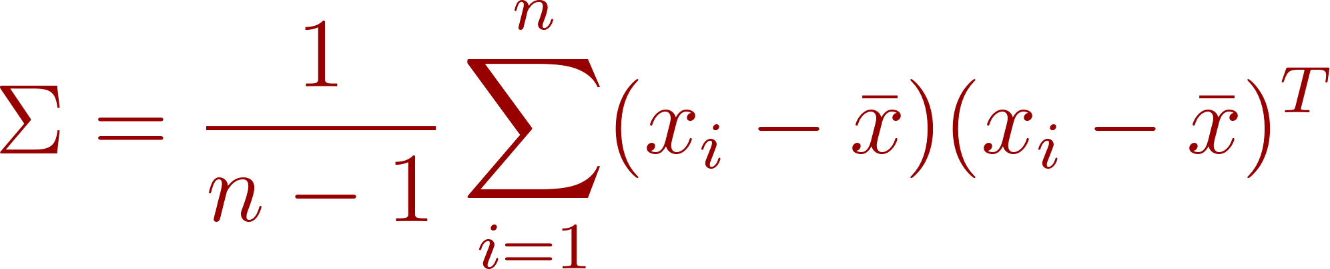
- Explained Variance Ratio:
To determine the optimal number of components, the importance of the -th principal component is evaluated by its eigenvalue () relative to the total sum of all eigenvalues:
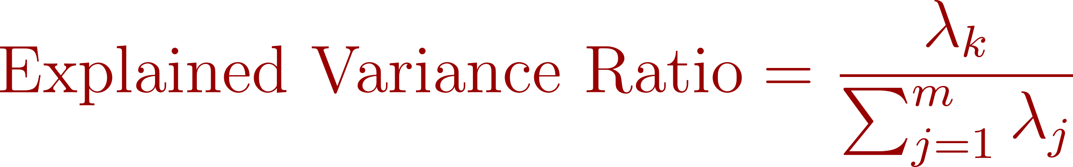

  - Model Selection
To ensure fair and reliable comparison between classifiers, both the holdout method and cross-validation were utilized during model development. The dataset was first divided using an 80–20 stratified train-test split, where 80% of the observations were allocated to model training and 20% were reserved for final testing. Stratification was applied to preserve the balanced class distribution across all 114 music genres. This resulted in approximately 91,199 training samples and 22,800 testing samples.

During hyperparameter optimization, 5-fold cross-validation was performed on the training subset. In this procedure, the training data was partitioned into five equal folds. For each iteration, four folds were used to train the model while the remaining fold was used for validation. This process was repeated five times so that each fold served once as validation data. The average validation performance across the five folds was then used to compare candidate hyperparameter settings.

For model tuning, the Macro F1-score was selected as the primary optimization criterion. Macro averaging gives equal importance to each genre class and is therefore suitable for this large multi-class classification problem where balanced performance across all genres is preferred over dominance in only a few classes. This was especially important given the 114-class prediction task.

After determining the optimal hyperparameters, each final model was retrained using the full training dataset and then evaluated once on the unseen holdout test set. This workflow reduces overfitting risk while providing an unbiased estimate of real-world predictive performance.

  - Evaluation Metrics
To comprehensively evaluate the performance of the classification models, multiple metrics were used. Since this project involves multi-class genre classification across 114 classes, relying on a single metric such as accuracy would be insufficient. Therefore, accuracy, precision, recall, F1-score, confusion matrix, ROC curve, and AUC were considered.

Accuracy
Accuracy measures the proportion of correctly classified observations out of all predictions made:
$Accuracy=\frac{TP+TN}{TP+TN+FP+FN}​$
Where:
- TP = True Positives, TN = True Negatives, FP = False Positives, FN = False Negatives
For multi-class classification, accuracy represents the percentage of tracks whose genres were predicted correctly.

Precision
Precision measures the proportion of predicted instances of a class that were actually correct:
$Precision = \frac{TP}{TP+FP}$
A high precision value indicates that when the model predicts a genre, it is often correct.

Recall
Recall measures the proportion of actual instances of a class that were successfully identified:
$Recall = \frac{TP}{TP+FN}$
High recall indicates the model can successfully detect most songs belonging to a specific genre.

F1-Score
The F1-score combines precision and recall into a single metric using their harmonic mean:
$F1=\frac{2×Precision×Recall}{Precision + Recall}$
For this project, Macro F1-score was emphasized. Macro averaging computes the F1-score independently for each genre and then averages the results, ensuring equal importance is given to all 114 classes.

Confusion Matrix
A confusion matrix provides a detailed comparison between actual and predicted labels. Each row represents the true genre, while each column represents the predicted genre. It is useful for identifying genres that are frequently misclassified as one another.

ROC Curve
The Receiver Operating Characteristic (ROC) curve plots the True Positive Rate (Recall) against the False Positive Rate:
$TPR= \frac{TP}{TP + FN}$ | $FPR = \frac{FP}{FP + TN}$
For multi-class classification, ROC analysis can be extended using a One-vs-Rest strategy.

AUC
The Area Under the ROC Curve (AUC) summarizes the ROC curve into a single value between 0 and 1. A higher AUC indicates stronger class separability and better predictive performance. Values closer to 1 indicate excellent classification ability, while values near 0.5 suggest random performance.

- Results
  - Data Preprocessing
This section presents a comprehensive report of the data preprocessing outcomes for the Spotify Tracks Dataset. The preprocessing was designed to transform the raw dataset into a format suitable for machine learning model training while preserving the integrity and interpretability of the high-level audio features. The final table for the dataset is as follows:

Preprocessing Step | Columns Before | Columns After | Rows After | Key Outcome
Missing Value Removal | 21 | 21 | 113,999 | 1 row dropped
Feature Selection (Drop Columns) | 21 | 16 | 113,999 | 5 cols removed
Binary Conversion (explicit) | 16 | 16 | 113,999 | bool → int
One-Hot Encoding (key, time_sig.) | 16 | 29 | 113,999 | +13 binary cols
Label Encoding (track_genre) | 29 | 29 | 113,999 | 114 classes → 0–113
Z-score Scaling (11 features) | 29 | 29 | 113,999 | μ=0, σ=1
Final Dataset | 21 | 29 features + target | 113,999 | Ready for modeling

Missing Value Removal:
Inspection revealed exactly one record with missing values across all 21 columns. This row was removed, reducing the dataset from 114,000 to 113,999 rows (a loss of 0.00088%). Imputation was not warranted given the negligible scale of missingness. The class balance across 114 genres remained effectively undisturbed, with the affected genre reducing from 1,000 to 999 samples.

Feature Selection:
Five columns were dropped as non-informative for genre classification:
- Unnamed: 0 — CSV row-index artifact.
- track_id — Unique alphanumeric identifier; no musical signal.
- artists, album_name, track_name — Free-text metadata. Artist identity in particular was excluded to prevent leakage: retaining it would allow models to memorize artist–genre associations rather than learn generalizable audio patterns.
This reduced the feature set from 21 to 16 columns, retaining 11 continuous audio features, 2 binary features, 2 categorical features, and the target label.

Feature Encoding and Scaling:
All remaining features were encoded or scaled as appropriate. The table below summarizes every transformation applied:

Feature | Original Type | Encoding Method | Result | Rationale
explicit | bool | Binary (0/1) | 1 int column | Model compatibility
mode | int (0/1) | None (verified) | Unchanged | Already binary
key | int (0–11) | One-hot encoding | 12 binary cols | No ordinal relationship between musical keys
time_signature | int (0,1,3,4,5) | One-hot encoding | 5 binary cols | Non-linear effect on genre
track_genre | string (114 classes) | Label encoding | int codes 0–113 | Multi-class target identifier
11 audio features | float / int, mixed scales | Z-score (StandardScaler) | μ=0, σ=1 each | Equalizes scale for k-NN and other models

A key design decision was fitting StandardScaler exclusively on the training partition, then applying those parameters to the test set. This prevents data leakage using test-set statistics during scaling would inflate reported model performance.
The one-hot encoded reference column was retained (no dummy drop) as tree-based classifiers are not affected by multicollinearity among binary indicators.

Final Preprocessed Dataset:
After all preprocessing steps, the final dataset ready for modeling has the following composition:
- Shape: 113,999 rows × 29 feature columns + 1 target column.
- 11 Z-score scaled continuous features, 2 unscaled binary features (explicit mode), 12 one-hot encoded key columns (key_0 – key_11), 5 one-hot encoded time_signature columns.
- Target: track_genre encoded as integers 0–113 (114 balanced classes, ~999–1,000 samples each).
The dataset contains no missing values, is fully numeric, and is appropriately scaled for both distance-sensitive (k-NN) and tree-based classifiers. The perfectly balanced class distribution means raw accuracy is a meaningful performance metric, with a random-guess baseline of approximately 0.88% (1/114).

  - Machine Learning Results
This section details the results of the multi-class genre classification experiments. Three supervised learning algorithms, Decision Trees, K-Nearest Neighbors (KNN), and Naïve Bayes, were evaluated to determine their efficacy in predicting 114 distinct musical genres. To assess the impact of feature space complexity on model performance, each algorithm was trained and tested on both the original feature set and a lower-dimensional subspace derived via Principal Component Analysis (PCA). In accordance with the project requirements, 12 principal components were selected, accounting for at least 90% of the total variance in the dataset. All models were evaluated using an 80-20 stratified holdout method, resulting in a training set of 91,199 samples and a testing set of 22,800 samples.
    - Decision Tree
Following the project guidelines, hyperparameters for the Decision Tree model were tuned individually to isolate their influence on the model’s size and complexity. The optimization process prioritized the Macro F1-score to ensure balanced performance across the 114 classes.
- Maximum Depth (max_depth): A refinement search determined the optimal depth to be 16, yielding a Macro F1-score of 0.1787.
- Minimum Samples Split (min_samples_split): Fine-tuning identified 45 as the optimal value, achieving a peak Macro F1-score of 0.1838.
- Minimum Samples Leaf (min_samples_leaf): Optimization established an optimal leaf size of 16, resulting in a Macro F1-score of 0.1829.
- Maximum Leaf Nodes (max_leaf_nodes): Performance peaked at 4,500 nodes (F1 = 0.1912), with higher counts leading to model overfitting.
- Pruning Parameters: Evaluations of ccp_alpha and Minimum Impurity Decrease showed that any value exceeding zero significantly degraded performance.

Comprehensive Performance Evaluation
The final optimized model was evaluated on both the PCA-reduced and original feature sets.

Feature Set | Accuracy | Macro Precision | Macro Recall | Macro F1-Score | AUC
Original Features | 0.2570 | 0.26 | 0.26 | 0.25 | 0.8530
PCA Features | 0.1928 | 0.18 | 0.19 | 0.18 | 0.8155

As shown in the table above, the model significantly outperformed the random baseline of 0.008 (1/114). The model trained on original features achieved notably higher performance than the PCA-reduced version, suggesting that the non-linear decision boundaries of the tree were better suited to the original feature space than the rotated PCA components. In conclusion, while the Decision Tree performed well on specific genres characterized by unique audio profiles, it encountered generalized difficulty across the majority of the dataset. This performance ceiling can be largely attributed to the high cardinality of the labels (C = 114) relative to the limited feature set (D = 16). The resulting disparity created significant overlap in the multidimensional space, making it statistically difficult for a single tree to accurately partition the data into 114 distinct and precise categories.

    - KNN
For the KNN model, a systematic hyperparameter search was carried out by tuning all three key hyperparameters in combination: the number of neighbors (k), the distance metric, and the weighting scheme. k was varied across 5, 7, and 9; the distance metric was tested as either Euclidean or Manhattan; and the weighting scheme was tested as either uniform or distance-based. The evaluation used 5-fold cross-validation with Macro F1-score as the main selection criterion so that all 114 genre classes were weighted equally. All combinations were evaluated on both the original and PCA-reduced feature sets, yielding 24 configurations in total.

The results showed three consistent patterns across both feature sets. First, Manhattan distance outperformed Euclidean distance at every value of k. Second, distance weighting outperformed uniform weighting in all cases, as it reduces the influence of farther neighbors. Third, performance improved steadily as k increased from 5 to 9. The best configuration overall was k = 9, Manhattan distance, and distance weighting on the PCA feature set.

Comprehensive Performance Evaluation
The following table reports the best combination per feature set:

Feature Set | Best k | Metric | Weights | CV Macro F1 | Test Accuracy | Test Macro F1 | AUC
Original Features | 9 | Manhattan | Distance | 0.2292 | 0.2365 | 0.2330 | 0.7210
PCA Features | 9 | Manhattan | Distance | 0.2362 | 0.2442 | 0.2403 | 0.7238

Based on the classification report of the best model, the final PCA-based KNN achieved an accuracy of 0.2442, with macro precision = 0.24, macro recall = 0.24, and macro F1-score = 0.2403 on the unseen test set. The confusion matrix showed that some genres were recognized more reliably than others, while several classes with similar audio patterns were still confused with one another. Compared with the original feature space, PCA clearly improved the KNN model, which makes sense because KNN relies directly on distance calculations and PCA reduces redundancy between features, making distance comparisons more meaningful. The macro-average AUC of 0.7238 indicates reasonable probabilistic class separability despite the low raw accuracy, which reflects the inherent difficulty of distinguishing 114 overlapping genres from hard predictions alone. Overall, the model performed far above the random baseline of approximately 0.0088 (1/114), but the results also confirm how difficult 114-class genre classification remains when many genres share similar high-level Spotify audio descriptors.

    - Naive Bayes
For the Naïve Bayes model, multiple probability-distribution variants were evaluated in accordance with the project guidelines. Specifically, three forms of Naïve Bayes were tested: Gaussian Naïve Bayes, Bernoulli Naïve Bayes, and Multinomial Naïve Bayes. Each variant was trained and evaluated on both the original feature set and the PCA-reduced feature set. Model selection again used 5-fold cross-validation with Macro F1-score as the primary criterion so that all 114 genres contributed equally to the evaluation. Because each Naïve Bayes variant assumes a different feature distribution, additional feature preparation was required:
- Gaussian Naïve Bayes was applied directly to the continuous standardized features.
- Bernoulli Naïve Bayes was trained on binarized versions of the data.
- Multinomial Naïve Bayes was trained on Min-Max scaled, non-negative features.

The resulting performance showed a clear difference between the variants.
● Gaussian NB with Original Features:
○ Performed poorly on the raw feature space.
○ Cross-validation Macro F1-score: 0.0502, Test accuracy: 0.0861, Test Macro F1-score: 0.0511
● Gaussian NB with PCA Features (Overall Best):
○ Produced the strongest Naïve Bayes result overall.
○ Cross-validation Macro F1-score: 0.1411, Test accuracy: 0.1779, Test Macro F1-score: 0.1422
○ Conclusion: PCA substantially improved Gaussian NB performance by reducing redundancy in the feature space and making the Gaussian class assumptions more suitable.
● Bernoulli NB with Original Features:
○ Achieved the second-best performance among all Naïve Bayes variants.
○ Cross-validation Macro F1-score: 0.1152, Test accuracy: 0.1486, Test Macro F1-score: 0.1163
● Bernoulli NB with PCA Features:
○ Performed worse than the original-feature Bernoulli model.
○ Cross-validation Macro F1-score: 0.0927, Test accuracy: 0.1301, Test Macro F1-score: 0.0928
● Multinomial NB with Original Features:
○ Showed limited effectiveness for this task.
○ Cross-validation Macro F1-score: 0.0767, Test accuracy: 0.0911, Test Macro F1-score: 0.0749
● Multinomial NB with PCA Features:
○ Produced the weakest results among the transformed-feature models.
○ Cross-validation Macro F1-score: 0.0625, Test accuracy: 0.0863, Test Macro F1-score: 0.0612

Comprehensive Performance Evaluation
The final optimized Naïve Bayes model was therefore the Gaussian Naïve Bayes model trained on PCA features. The following table compares the best-performing version from each Naïve Bayes distribution family.

Variant | Feature Set | CV Macro F1 | Test Accuracy | Test Macro F1 | AUC
Gaussian NB | PCA Features | 0.1411 | 0.1779 | 0.1422 | 0.8629
Bernoulli NB | Original Features | 0.1152 | 0.1486 | 0.1163 | 0.8460
Multinomial NB | Original Features | 0.0767 | 0.0911 | 0.0749 | 0.7907

Based on the classification report of the best model, the PCA-based Gaussian Naïve Bayes achieved an accuracy of 0.1779, with macro precision = 0.15, macro recall = 0.18, and macro F1-score = 0.14 on the unseen test set. The results indicate that Naïve Bayes was able to capture some broad genre structure, but it struggled to separate many overlapping classes. This is reflected in the large number of genres with very low precision or recall and in the confusion matrix, where several classes with similar high-level Spotify attributes were frequently mixed together.

Compared with the other algorithms used in this project, Naïve Bayes was less effective overall. This is expected because the method assumes conditional independence between features, an assumption that is often unrealistic for audio descriptors such as danceability, energy, loudness, and valence, which are often correlated. Nevertheless, the model still performed well above the random baseline of approximately 0.0088 (1/114), and the improvement obtained from PCA suggests that dimensionality reduction can partially mitigate the limitations of simple probabilistic classifiers in high-cardinality genre classification tasks.

- Discussion
The table below summarizes the best result achieved by each algorithm on the original feature set and on the PCA-reduced feature set. Overall, the optimized Decision Tree trained on the original features gave the best performance in the project, while KNN benefited the most from PCA.

Algorithm | Best Original | Accuracy | Macro F1 | AUC | Best PCA | Accuracy | Macro F1 | AUC
Decision Tree | Optimized tree | 0.2570 | 0.25 | 0.8530 | Optimized tree | 0.1928 | 0.18 | 0.8155
KNN | k=9, Manhattan, Distance | 0.2365 | 0.2330 | 0.7210 | k=9, Manhattan, Distance | 0.2442 | 0.2403 | 0.7238
Naive Bayes | Bernoulli NB | 0.1486 | 0.1163 | 0.8460 | Gaussian NB | 0.1779 | 0.1422 | 0.8629

The clearest pattern in the results is that PCA did not affect every algorithm in the same way. Decision Tree performed best on the original features, with accuracy = 0.2570 and macro F1-score = 0.25, while its PCA version dropped to 0.1928 accuracy and 0.18 macro F1-score. In contrast, KNN improved from 0.2365 accuracy and 0.2330 macro F1-score on the original features to 0.2442 accuracy and 0.2403 macro F1-score after PCA. Naive Bayes also benefited from dimensionality reduction, with Gaussian Naive Bayes on PCA features reaching 0.1779 accuracy and 0.1422 macro F1-score, which was clearly better than the other Naive Bayes variants. This suggests that PCA was most helpful for the distance-based and probabilistic models, but not for the tree model, which could use the original feature space more effectively.
These findings partially agree with the literature review. Section 2 noted that tree-based methods were generally stronger than KNN and Naive Bayes, and our results follow the same overall pattern because the Decision Tree achieved the best performance of the three algorithms. Unlike the feature-reduction result discussed in Section 2, however, reducing the feature space did not help every model in our notebook. Our absolute scores were also much lower than the values reported in the literature. A likely reason is that our task is more difficult: the notebook uses 114 balanced genres, so the classifier has to separate many classes with overlapping audio characteristics. This is very different from smaller-genre settings or studies that do not fully document preprocessing and evaluation details.

Another important point is that the high-level Spotify features were useful, but they were not enough to separate all genres cleanly. All three models performed far above the random baseline of about 0.0088, so the features do carry meaningful genre information. However, the classification reports and confusion matrices show that some genres were still mixed because many classes share similar values for features such as danceability, energy, loudness, and valence. From a practical point of view, the best overall model in this project was the tuned Decision Tree on the original features, while the best PCA-based model was KNN with k = 9, metric = Manhattan and weights = Distance.

- Conclusion
This project presented a reproducible, end-to-end pipeline for multi-class music genre classification using high-level audio features from the Spotify Tracks Dataset. Three classical supervised learning algorithms, Decision Trees, K-Nearest Neighbors, and Naïve Bayes, were systematically benchmarked across both the original feature set and a PCA-reduced representation. Preprocessing steps including listwise deletion, one-hot encoding, binary conversion, and Z-score standardization were applied to ensure data integrity and model compatibility. Dimensionality reduction via PCA was evaluated across all models, revealing that its benefit was algorithm-dependent: KNN and Gaussian Naïve Bayes improved under PCA, while the Decision Tree performed better on the original feature space.

The best-performing model overall was the optimized Decision Tree trained on the original features, achieving an accuracy of 25.70% and a Macro F1-score of 0.25, far exceeding the random-guess baseline of approximately 0.88% across 114 genres. While these scores remain lower than figures reported in the literature, this is largely attributable to the substantially higher label cardinality of the task, as most prior studies classify fewer than 15 genres. The primary bottleneck identified is the semantic overlap between genres in the high-level Spotify feature space, where attributes such as danceability, loudness, and valence fail to cleanly separate many genre pairs.
References
[1] maharshipandya, “spotify-tracks-dataset,” Hugging Face Datasets, 2025. Available: https://huggingface.co/datasets/maharshipandya/spotify-tracks-dataset?library=datasets.
[2] Cabansag, I. J., & Ntegeka, P. (2025, May 22). Prediction of Spotify Chart success using audio and streaming features. arXiv.org. https://arxiv.org/abs/2508.11632
[3] Du, J. L. (2022). Spotify between decades: Hit or miss predictor (Master’s thesis, Tilburg University, School of Humanities & Digital Sciences, Department of Cognitive Science & Artificial Intelligence). Tilburg University. https://arno.uvt.nl/show.cgi?fid=160898
[4] S. Jiang, “Predicting Music Popularity: A Machine Learning Approach Using Spotify Data,” Proceedings of the 1st International Conference on Modern Logistics and Supply Chain Management. SCITEPRESS - Science and Technology Publications, pp. 324–328, 2024. doi: 10.5220/0013330000004558.
[5] L. Feng, S. Liu, and J. Yao, “Music Genre Classification with Paralleling Recurrent Convolutional Neural Network,” 2017, arXiv. doi: 10.48550/ARXIV.1712.08370.
[6] R. Singhal, S. Srivatsan, and P. Panda, “Classification of Music Genres using Feature Selection and Hyperparameter Tuning,” JAICN, vol. 4, no. 3, pp. 167–178, Aug. 2022, doi: 10.36548/jaicn.2022.3.003.
[7] M. Fiqri, et al., “Implementation of Supervised Learning Algorithm on Spotify Dataset,” International Journal of Advanced Technology and Information Systems (IJATIS), vol. 2, no. 1, 2025. doi: 10.57152/ijatis.v2i1.1123.
[8] Y. Wu, “Predicting Hit Songs Using Spotify Tracks Dataset,” Scholarly Review, Winter 2025/2026. doi: 10.70121/001c.154965.

